Chapter 14, Solution 18.

The MATLAB code is shown below.

>> w=logspace(-1,1,200);
>> s=i*w;
>> h=(7*s.^2+s+4)./(s.^3+8*s.^2+14*s+5);
>> Phase=unwrap(angle(h))*57.23;
>> semilogx(w,Phase)
>> grid on

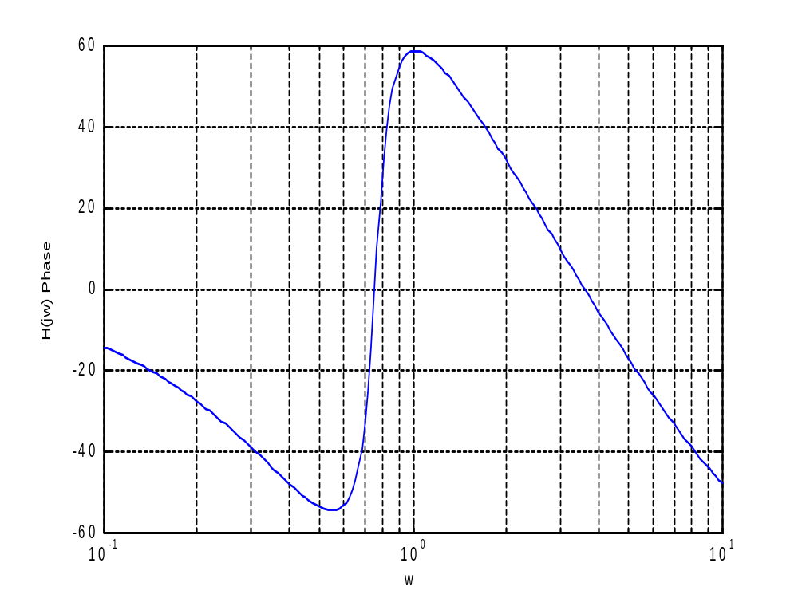
Now for the magnitude, we need to add the following to the above,

>> H=abs(h);
>> HdB=20*log10(H);
>> semilogx(w,HdB);
>> grid on

